An Apple a Day…
Inspired by


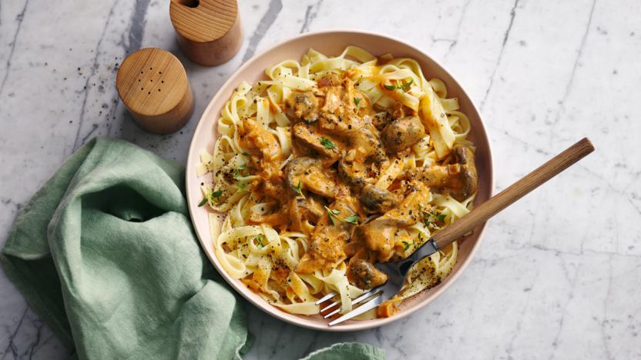
DID YOU KNOW?
“Apples contain quercetin, which has been shown to have anti-inflammatory, anti-viral, anti-cancer, and anti-depressant effects. So these are a very healthy snack…. An apple a day keeps the doctor away! Right?!”

Nutrition – Total / Per Cupcake
Calories: ??kcal / ?kcal
Carbohydrates: ?g / ?g
Protein: ?g / ?g
Fat: ?g / ?g
Fibre: ?g / ?g
Sugar: ?g / ?g
Ingredients (makes ~6 cupcakes)
90g plain flour
2 tbsp maple syrup
180ml almond milk
40ml olive oil
1 granny smith apple
½ tsp salt
½ tbsp lemon juice
1 tsp baking powder
1 tsp vanilla extract
2 tsp ground cinnamon
2 tbsp sugar
2 tbsp melted butter






Good for:

Star Rating:



Method

Step 1 – Get it Ready
Preheat the oven to 200°C.
Line your muffin tray with liners or lightly grease.
Whisk the plain flour, salt, baking powder, 1 tsp ground cinnamon together in a large bowl.

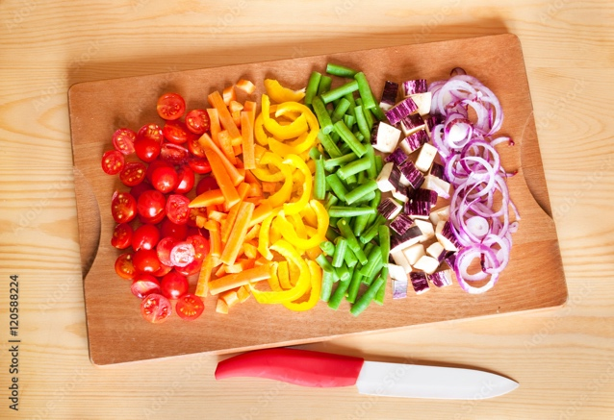

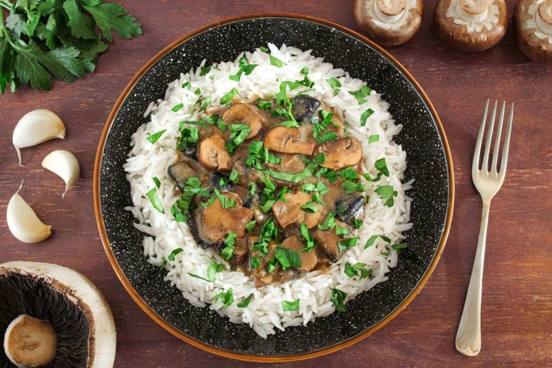
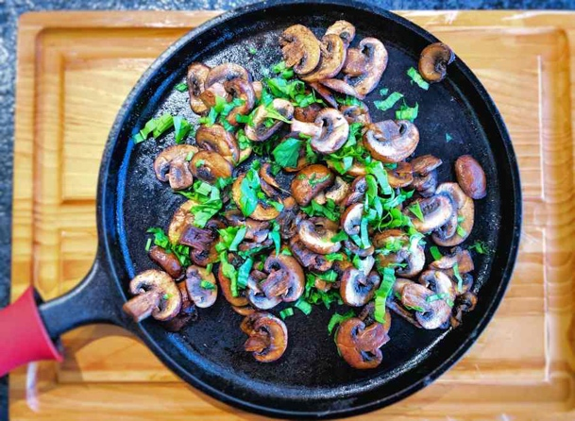
Step 4 – Butter Me Up
Mix the 1 tsp ground cinnamon and sugar together.
Melt your butter and brush onto the tops of your muffins (or dip the tops).
Then dip the muffins into the sugar and cinnamon mixture to coat the tops.
Let them cool before eating.

Enjoy!
Step 2 – Keep it Moist
In another bowl, mix the almond milk, olive oil, lemon juice, maple syrup, and vanilla extract.
Slowly pour in the mixture of the wet ingredients into the large bowl with the dry ingredients, mixing until combined.
Once the batter has been combined, add in the apples.
Gently fold them in, be careful not to overmix or mix too hard.
Step 3 – Batter Me Up
With a tablespoon, spoon your batter into the muffin cups right to the top.
Bake for ~15 minutes or until lightly golden on the top.
Ensure that they are fully cooked through by inserting a knife/toothpick into the centre of the muffin and seeing if it comes out clean.
Allow to cool before putting on the topping (or even having a sneaky taste test!).

